**05 – Complex Impedance**

**Topics:** Complex impedance, phasor diagrams, RLC circuits, *leading* vs. *lagging*

**Summary:** These activities are meant to help students gain facility with different representations of complex functions, and with relating them to the behavior of an *RLC* circuit. They begin by plotting voltage (and current) relative to a given current (or voltage), using a specific value for the complex impedance. They can compare their answers with trigonometric representations, and resolve difficulties in deciding whether one function *leads* or *lags* the other in time. Students then determine the total impedance in an *RLC* circuit in terms of the impedance for each circuit element, and plot various vectors in a phasor diagram to see how they are related.

**Written by:** Michael Dubson, Charles Baily and Steven Pollock.

**Contact:** Steven.Pollock@Colorado.EDU

**Comments:** Students should be able to complete these activities in less than 50 minutes. It is assumed they have either completed the previous activities on complex exponentials, or had some kind of introduction to writing complex numbers in various forms, and the multiplication of complex exponentials (frequent errors come from not being familiar enough with the rules of exponents). Many students were initially not careful about the magnitudes of the vectors they drew in the phasor diagrams on the first page. When graphing the current on pg. 2, a significant number of students were too quick to simply plot a regular sine function and move, without considering the actual phase of the current relative to the voltage. Some students were forgetful about the condition  when graphing the various impedances (on pg. 3), or it wasn’t immediately obvious to them how this was relevant to what they were graphing. There has also been a great deal of confusion among students concerning whether the voltage is leading or lagging the current, depending on which representation being used. It seems to be fairly intuitive for them when looking at the phasor diagrams (as long as they’re clear on the direction in which the vectors are rotating with time); but the trigonometric representations can be challenging for them because, in the graph of a function that is *leading* in time, it peaks at a point that is to the physical left of the peak for the function it leads, and therefore “looks” like it’s actually lagging. We believe the representation in the complex plane is superior in this regard.

**A.** Given  and the complex number  shown in the diagram below, plot the complex number 

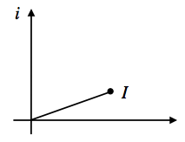

Given  and , plot the complex number  at the instant in time shown in the diagram below.

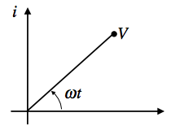

**B.** For the same situation as before, with  and , sketch the real (physical) values of  as functions of time in the graphs below.

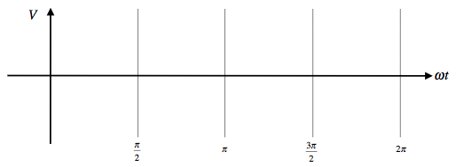

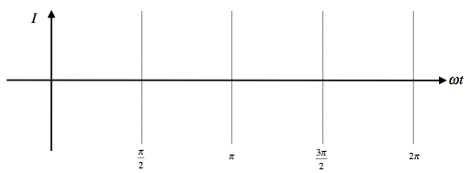

Does the current *lead* or *lag* the voltage? Make sure your answers on this page are consistent with the phasor diagram you drew on the previous page for the same situation.

You may continue, but be sure to check your answers to this part with an instructor.

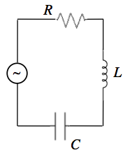**C.** The complex impedances for the following circuit elements are:

  

What is  for this circuit?

Write  in the form .

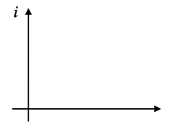**D.** For graphing purposes, assume that . Sketch , , , and show how they add as vectors to get .

Under what circumstances does the current *lead* the voltage?

Under what circumstances are the current and voltage *in phase*?